VVDI2 Key Programmer

This VVDI2 Version comes with Basic Function + VW + BMW + Porsche+PSA+ AUDI Generation 5 Function+BMW OBD Fucntion+BMW CAS4+ Functions +Tango + J2534.

VVDI2 Covers All the Functions of VVDI, VVDI 5th IMMO Adapter, BMW Multi Tool, CAS4 Adapter, Tango & J2534.

**Reasons to Get VVDI2:**

* 1. This VVDI2 Full Package Contains Basic Function + VW + BMW + Porsche+ PSA + AUDI Generation 5 Function + BMW OBD Fucntion + BMW CAS4 Functions + Tango + J2534  
     2. VVDI2 Full Package Covers All the Functions of [VVDI](http://www.uobdii.com/wholesale/vag-vehicle-diagnostic-interface-vvdi.html), [VVDI 5th IMMO Adapter](http://www.uobdii.com/wholesale/vvdi-5th-immo-update-tool.html), [BMW Multi Tool](http://www.uobdii.com/wholesale/bmw-multi-tool.html) & CAS Plus for BMW Multi Tool  
     3. Support VW, Audi, BMW, Porsche & PSA  
     4. Update Online Free Lifetime

**This VVDI2 Version with Activated Software List as below:**  
  
1) VV-01 VAG 4th immobilizer  
2) VV-02 VAG 5th immobilizer  
3) VV-04 ID48 96Bit Copy  
4) VV-05 VAG MQB Immobilizer  
5) VB-01 BMW OBD  
6) VB-02 BMW CAS4  
7) VP-01 Porsche immo data tool  
8) VPSA-01 PSA  
9) VK-01 Transponder Programmer  
10) VJ-01 Passthru J2534  
Notice: No VV-03 VAG Copy 48 transponder by OBDII and VB-03 FEM/BDC Function in this package.

**J2534 Compatible Adapter**

**1.Detect key frequency, automatically identify chip type**

The test result can show on the main unit display, no need to connect computer

**2. Support VAG vehicle diagnostic function**

Read & write Immo4/Immo5 system

Learn key

Program BCM remote

K-Line instrument immobilizer box

Correct odometer

Program control unit

Unlock Immo1/Immo2 firmware protection

Support data manipulation tools

**3. Support OBD functions on BMW vehicles**

Correct odometer

Generate key

Unlock Key

**4. Fix CAS4 EEPROM key programmer**

Generate specialized chips

Immobilizer data processing tool

Other key tools

Generate remote control

**5. Passthru J2534 Introduction**

With built-in switch matrix, it supports third-party diagnostic software including:  
ODIS, Toyota TIS techstream etc. To perform VVDI2 diagnostic function, third-party diagnostic software should be compatible with J2534 function.

**VVDI2 – VAG software:**  
VAG software support VAG cars: VW, Audi, Seat, Skoda, 4 th immobilizer Porsche, 4 th immobilizer Bentley .  
Mainly include: Diagnostic, 4 th immobilizer, 5 th immobilizer, key learn, BCM remote control, Engine control unit, Kline instrument and immobox, adapt unit, component protection,dump tool etc.  
  
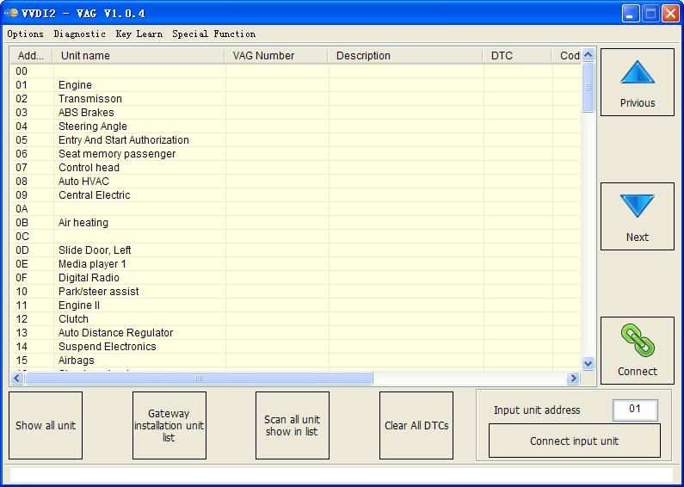  
  
**\*Diagnostic**  
Support TP2.0, UDS, KWP1281, KWP2000 protocol, have internal database, can display every item in detail  
Identification: read the detail information for target unit  
Coding: Set unit coding  
Actuator test: Test every small actuator in target unit  
Read DTCs: Read trouble codes  
Clear DTCs: Clear trouble codes  
Basic settings: Complete basic settings for target unit  
Security access: Login with PIN code, usually use before adaptation  
Adaptation: Set new value in channel  
Custom requests: You can write your own commands to unit  
Measured values: Display useful information from channel  
Advance measure value: Display one item information in group (mainly for UDS protocol)  
ECU Flasher: Support flash ECU by OBDII, now we support frf, odx, sgo file  
  
**\*Key Learn**  
  
**4th immobilizer system** – VW/Audi/Skoda/Seat/Porsche/Bentley all have cars with 4th immobilizer. For 4th immobilizer cluster, support Read/Write EEPROM, Read/Write immodata, change KM, add new key, read START/STOP key data etc  
1) Instrument - CDC3217/CDC3297/CDC3272 + 24C2  
2) Instrument - NEC+24C32  
3) Instrument - NEC+24C64  
4) Instrument - NEC+24C64 (2013-)  
5) Instrument– NEC+24C64 (2012 TFT color display)  
6) Instrument– NEC+24C64 (2013 TFT color display)  
7) Instrument– NEC35xx  
8) Instrument– NEC+95320  
9) Instrument– Motorola 9S12XHZ512(Golf6 MM7 – 2011)  
10) Instrument– NEC+95320(Johnson Controls)  
11) Instrument– NEC+95320(JCI – 2013 Bora/Jetta)  
12) Instrument– Visteon  
13) VW Passat B6/B7/CC Key Learn  
14) Touareg/Phaeton/A8/Cayenne/Bentley 4th immobilizer  
15) Audi A1 – NEC+24C64  
16) Audi A3/TT/R8 – CDC3217/3297 + 24C32  
17) Audi A4 – instrument Crypto RB4 (2001+)  
18) Audi A4 –instrument Crypto RB8 (2004+)  
19) Audi A6/Q7/Allroad – EZS-Kessy  
20) Audi Q3  
  
**5th immobilizer system** – VW/Audi  
Support following cars: A4(2009- ), A5, Q5, A6 (2012-), A7, A8(2011-), Touareg(2011-)  
1) OBD method read BCM2  
2) BDM method read BCM2  
3) Check key status  
4) Make Dealer key  
5) Key Learning  
  
**Key Learn**  
Support learn dealer key by OBD for most of the vehicles (Auto detect type is supported). Supports following types:  
1) Audi A4/A6 (immobilizer box) -1997 - KWP1281  
2) Audi A8 (immobilizer box) -1999 - KWP1281  
3) Audi A2/A3/A6/TT/Allroad 1997+ - KWP1281  
4) Audi A4 1997-2002 - KWP1281  
5) Audi A4 2002+ - KWP2000  
6) Audi A8 1999-2002 - KWP1281  
7) Audi A3 - CAN  
8) Audi A6/Q7/Allroard 2005+ - CAN (Support OBD lost all key)  
9) Seat Altea -2007 - CAN  
10) Seat Cordoba  
11) Seat Ibiza (immobilizer box) -1999 - KWP1281  
12) Seat Ibiza 1999+  
13) Seat Leon - KWP1281  
14) Seat Leon -2007 - CAN  
15) Seat Toledo - KWP1281  
16) Seat Toledo -2007 - CAN  
17) Skoda Octavia - KWP1281  
18) Skoda Octavia II -2007 - CAN  
19) Skoda Octavia II 2007+ - CAN  
20) Skoda Superb - KWP1281  
21) Skoda Roomster - KWP1281  
22) Skoda Scout -2007 - CAN  
23) Skoda Fabia (immobilizer box) -1999 - KWP1281  
24) Skoda Fabia 1999+ - KWP1281  
25) VAG (immobilizer box) - KWP1281  
26) VAG KWP1281 Immobilizer - KWP1281  
27) VAG KWP2000 Immobilizer - KWP2000  
28) VW Polo (PCF7935 transponder) - KWP1281  
29) VW Touareg/Phaeton/Bentley/Cyenne Kline - KWP2000  
30) Audi A8 - CAN  
31) VW, Seat, Skoda -2007 - CAN  
32) Porsche Cayenne CAN - CAN  
33) VW Passat B6/CC – CAN (Support OBD lost all key)  
34) VW Passat B6/CC with EDC17/MED17 – CAN (Support OBD lost all key)  
35) VW Golf V with Visteon dash  
36) Audi A4 (RB8 Instrument Cluster) 2004+ - KWP2000  
37) VW, Seat, Skoda 2007+ - CAN (Support OBD lost all key)  
38) VW, Seat, Skoda, Audi with VDO NEC 2009+ - UDS (Support OBD lost all key)  
39) Lamborghini Gallardo -2005  
40) Lamborghini Gallardo 2005+  
41) VW with NEC+95320 or Magneti Marelli with Motorola 9S12 2009+ - UDS (Support OBD lost all key)  
42) Immobilizer box use Megamos - KWP1281  
43) New Beetle - KWP2000  
44) Johnson Controls with 95320 - UDS (Support OBD lost all key)  
45) VW Dashboard with VDO NEC35xx 2013+ - UDS (Support OBD lost all key)  
  
**\*Remote Key Adaptation**  
Support adapt remote key with 09 unit (BCM system and BFM system) (4th immobilizer – UDS dashboard)  
  
**\*Special Function**  
Engine Control Unit  
OBD operation: read PIN, CS, MAC, change KM, switch OFF/ON immo, read flash. Also VVDI2 provide auto detect function. Supports following types:  
1) ME7.1.1/7.5/7.8 master  
2) ME7.1.1/7.5/7.8 slaver  
3) MED17  
4) MED 9.1 single  
5) MED 9.1 master  
6) MED 9.1 slaver  
7) MED 9.5.10  
8) EDC15x  
9) EDC16U1  
10) EDC16U1 master  
11) EDC16U1 slaver  
12) EDC16U31  
13) EDC16U31 master  
14) EDC16U31 slaver  
15) EDC16U34  
16) EDC16CP/EDC16CP34  
17) EDC16CP34 master  
18) EDC16CP34 slaver  
19) EDC16C4 master  
20) EDC16C4 slaver  
21) EDC17  
22) SIMOS PPD 1.1/1.5(Siemens)  
23) SIMOS benzin(Siemens)  
24) Porsche 5.2/7.8  
  
**\*K-Line Instrument/Immobox**  
OBD operation: Read pin code from Kline cluster and immobox, Read/Write EEPROM, change KM etc  
Supports following types:  
1) Instrument Cluster(VDO66,VDO86, Motometer)  
2) VW LT immobilizer box  
3) VW Gol immobilizer box  
4) White immobilizer box - Audi A4/A6/A8  
5) Black immobilizer box Siemens 6 PINs HC05 (Immo1)  
6) Black immobilizer box Siemens 6 PINs HC05 - 2400 (Immo1)  
7) Black immobilizer box Siemens 6 PINs TMS (Immo1)  
8) Instrument Cluster - Audi A4 B5 with Board Computer (-1997)  
9) Instrument Cluster - Audi A4 B5 without Board Computer (-1997)  
10) Instrument Cluster - Audi A8 (-10.1996)  
11) Instrument Cluster - Audi A8 (11.1996-)  
12) Instrument Cluster - Audi A6 B45 (-1997)  
13) Instrument Cluster - Magneti Mareli - Shadow 1  
14) Instrument Cluster - Magneti Mareli - Shadow 2 (Passat)  
15) Instrument Cluster - Magneti Mareli - Shadow 3 (TT)  
16) Instrument Cluster - Magneti Mareli - Direct 1996-2000  
17) Instrument Cluster - Magneti Mareli - Direct 2000-  
18) Instrument Cluster - Sharan/Galaxy (-2000)  
19) Instrument Cluster - Audi A4 BOSCH RB4 Crypto 2001+  
20) Instrument Cluster - VW Golf 4 BOSCH RBx  
21) Instrument Cluster - Audi A4 BOSCH RBx  
22) VW Phaeton/Touareg, Bentley Continental, Porsche Cayenne  
23) Instrument Cluster - Audi A4 BOSCH RB8 Crypto 2004+  
24) Instrument Cluster - Lamborghini Gallardo -2005  
25) Instrument Cluster - Lamborghini Gallardo 2005+  
  
**\*Change KM**  
(4th immobilizer UDS cluster enter 4th immobilizer for change KM, Kline cluster enter Kline cluster and immobox change KM)  
Supports following types:  
1) CAN Instrument - A4(2009-)/A5/Q5  
2) CAN Instrument - A6/Q7/Allroad (-2011)  
3) CAN Instrument - A8 (2003-2011)  
4) CAN Instrument – Touareg/Phaeton (2007-2010)  
5) CAN Instrument – VW Touareg(2010-)/Audi A6(2012-),A7, A8(2011-)  
6) CAN Instrument– VW Lavida(China)1.6, 2.0 (NEC+24C08)  
7) K-Line Instrument– Touareg/Phaeton (-2007)  
  
**\*Adapt Unit**  
This can adapt 2nd unit to new car, synchronization ECU with immobilizer. Supports following types:  
1) ECU (EDC16/EDC17/MED9/MED17/Simos) – 4th immobilizer ECU  
2) Kessy Audi A8, VW Touareg/Phaeton  
3) Passat B6 /CC Comfort module  
4) A6/Q7/Allroad Transmission gearbox  
5) Electrical Steering Colum Lock(PQ35)  
6) A6/Q7/Allroad EZS-Kessy  
  
**\*Component protection**  
1) Generation 1  
a) Audi A6/Q7 (2004-2009) - 07 - Control Head (MMI)  
b) Audi A6/Q7 (2004-2009) - 09 - Central electric (ILM Fahrer)  
c) Audi A6/Q7 (2004-2009) - 0E - Media Player 1 (MP3 CD Changer)  
d) Audi A6/Q7 (2004-2009) - 18 - Auxilary Heater  
e) Audi A6/Q7 (2004-2009) - 46 - ILM Front passenger (ILM Beifahrer)  
f) Audi A6/Q7 (2004-2009) - 06 - Seat Memory Passenger  
g) Audi A6/Q7 (2004-2009) - 36 - Memory module (Driver's seat)  
h) Audi A8 (2003-2006) - 17 - Instrument Cluster  
i) Audi A8 (2003-2010) - 06 - Seat Memory Passenger  
j) Audi A8 (2003-2010) - 36 - Memory module (Driver's seat)  
k) Audi A8 (2003-2010) - 47 - DSP Bang & Olufsen  
  
2) Generation 2 – Audi A6/Q7/Allroad other control unit, Audi A4/A5/Q5 control unit Support following modules: Entry And Start Authorization, Airbags, Instruments, Central Electric, Central Comfort Module, Seat Memory Driver, Auto HVAC, Auxiliary heater, Seat memory passenger, Sound System, Control head, Information Electric, Radio etc  
  
**\*EEPROM dump tool**  
Support decode ECU EEPROM, Kessy module, J518 module, comfort module, change KM for cluster EEPROM dump  
ECU EEPROM: decode PIN, CS, MAC, set new PIN，CS，MAC values Immobox EEPROM: Kessy module(93C86), J518 module, comfort module, decode PIN，CS，Immo NO., VIN etc Cluster and immobox EEPROM: decode PIN, KM, and change KM Support following types:  
1) IMMO - KESSY - Audi A8, VW Touareg, VW Phaeton, Porsche Cayenne, Bentley Continental [93C86]  
2) EZS-Kessy Security access code / component protection data [9S12]  
3) Passat B6 Comfort module component protection data [95320]  
4) ECU Magneti Marelli(MM7GV, used in part NEC35xx type) PIN and component protection data [95320]  
5) ECU EDC16 Set component protection data [95320]  
6) ECU EDC16 Immo bypass [95320]  
7) ECU EDC16 Mileage calculator [95320]  
8) ECU EDC16 Security access code / Checksum calculator [95320]  
9) ECU EDC16 Speed Limiter [95320]  
10) ECU EDC16 Make virgin [95320]  
11) ECU MED 9.x Reset component protection data [95160]  
12) ECU MED 9.x Security Code / Checksum calculator [95160]  
13) ECU MED 9.x Reset component protection data [95080]  
14) ECU MED 9.x Security Code / Checksum calculator [95080]  
15) ECU MED 9.x Reset CRYPTED Login/Component protection  
16) ECU MED 9.x Reset flash counters  
17) ECU MED 9.x Immo Bypass  
18) ECU ME 7.x Set component protection data [9P08/95080]  
19) ECU ME 7.x Security Code / Checksum calculator [9P08/95080]  
20) ECU ME 7.x Immo Bypass [9P08/95080]  
21) ECU EDC15 Immo bypass [24C04]  
22) Gateway Mileage resetter [95160]  
23) Steering lock VW Passat 6 Security code [68HC908]  
24) ECU Simos Benzin - Immo bypass  
25) ECU Simos 7 - K-line - Login code [93C76] [93C86]  
26) ECU Simos 7 - CAN - Security Access Code [93C76] [93C86]  
27) ECU Simos 7 - CAN - Reset component protection data [93C76] [93C86]  
28) ECU Simos 6.x - Security Access Code  
29) ECU Simos 6.x - Reset component protection data  
30) ECU Simos PPD1x - Reset component protection data  
31) ECU Simos PPD1x - Mileage calculator  
32) ECU Simos PPD1x - Security Access Code  
33) ECU Simos 9.1 - Reset component protection data  
34) ECU Simos 9.1 - Security Access Code  
35) ECU Simos 9.2 - Reset component protection data  
36) ECU Simos 9.2 - Security Access Code  
37) ECU Simos 6.3 - Reset component protection data  
38) ECU Simos 6.3 - Security Access Code  
39) ECU Simos 3.3 - Security Access Code and CS bytes  
40) ECU Magneti Marelli Security Access Code [95320]  
41) ECU Magneti Marelli - Reset component protection data [95320]  
42) ECU Magneti Marelli Security Access Code [95080]  
43) ECU Simos 9.1 (Polo 2007) - Security Access Code  
44) ECU Bosch M3.x - Immo bypass  
45) ECU MSA1x - Immo bypass  
46) IPC VDO VW/Seat/Skoda (2007+) Micronas  
47) IPC - CRYPTO Skoda Fabia, Skoda Roomster, VW Polo, Seat Ibiza [ 93C86 ]  
48) Magneti Marelli MM4 Instrument mileage and login code [HC12]  
49) Audi A3/A4/A6 UKNSI 1995-1997 mileage and login code [93C56]  
50) Audi A3/A4/A6 UKNSI 1997-1998 mileage and login code [93C56]  
51) Audi A3/A4/A6 UKNSI Japan mileage and login code [93LC56]  
52) Audi 100 VDO 1995 mileage [94C46]  
53) Golf 3 VDO 1995 mileage [93C46]  
54) Golf 3 VDO V3.9 mileage [93C46]  
55) Golf 3 Diesel mileage [93C46]  
56) Golf 3 Motometer V5.8 mileage [93C56]  
57) Polo Motometer mileage [93C46]  
58) Polo Motometer 1996 mileage [93C66]  
59) Passat VDO 1991 mileage [93C56]  
60) Passat VD202 1993 mileage [93C46]  
61) Passat GT mileage [93C46]  
62) Passat GT mileage [93C56]  
63) Caddy mileage [93C56]  
64) Corrado VDO 1993 mileage [93C46]  
65) Corrado MotoMeter 1991-1995 mileage [93C56]  
66) Corrado VDO 1991-1995 mileage [93C56]  
67) Jetta 1994-1996 mileage [93C46]  
68) T4 MotoMeter 1996-1997 mileage [93C56]  
69) Audi A8 (-2002) - Security access code [24c17]  
70) Audi A8 (-2002) - Mileage calculator [24c17]  
71) Polo TRW [24c08] - Security access code  
72) Black immobilizer box VALEO 24C04 - Security access code  
  
**VVDI2 – BWM software**  
 BMW software support cars: BMW. Support types can be find in Mainly function: Read/Write EWS, read CAS information，Read/Write CAS EEPROM,  
Read/Write KM stored in CAS, synchronization DME with CAS, synchronization CAS with ELV, Key Learn(immo)，File Make Key, Unlock Key, File Change KM, CAS Repair etc OBD Flash ISTA version only need 10 minutes. (No extra power. No backup CAS EEPROM and FLASH).  
  
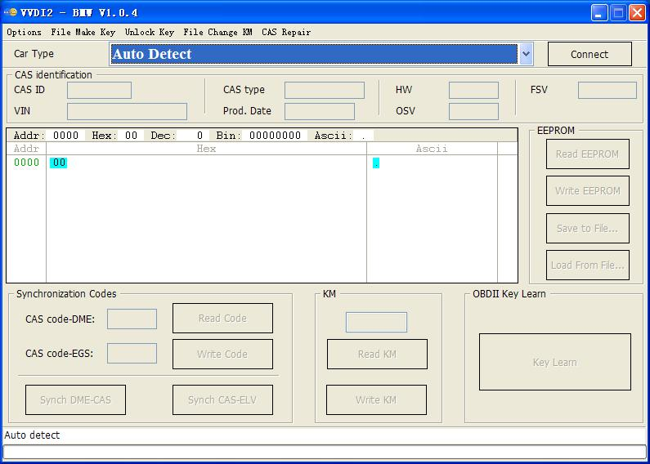  
  
**OBD Function**  
Support CANBUS100, CANBUS500 and KWP protocol.  
Diagnostic CAS information  
Key Learn  
1) Get Key Info  
2) Write Key Info  
3) Prepare dealer key with programmer (Support CAS1, CAS2, CAS3, CAS3+, ISTAP)  
4) Prepare dealer key with ignition switch (Support CAS1, CAS2, CAS3, CAS3+, ISTAP)  
5) Program Key info  
6) Enable/Disable Key (Support CAS1, CAS3, CAS3, CAS3+, CAS4, CAS4+)  
7) Clear DTC/Shadow  
  
  Read/Write CAS EEPROM  
  Change KM stored in CAS  
  Read/Write synchronization codes stored in CAS  
  Synch DME – CAS  
  Synch CAS – ELV  
  Read/Write EWS EEPROM  
  
**File Make Key**  
Support following types:  
  EWS1  
  EWS2  
  EWS3  
  EWS4  
  CAS1(0K50E)  
  CAS2(2K79X)  
  CAS3(0L01Y)  
  CAS3+(0L15Y/0M23S): Support encrypt version and ISTAP version  
  CAS4 (F - Series 1L15Y)  
  CAS4 (F - Series 5M48H): Support CAS4 encrypt version  
  
**File Change KM**  
Support following types:  
  EWS3  
  EWS4  
  CAS1(0K50E)  
  CAS2(2K79X)  
  CAS3(0L01Y)  
  CAS3+(0L15Y/0M23S)  
  CAS4 (1L15Y)  
  CAS4 (5M48H)  
  M35080(E – Series cluster)  
  
  F - Series cluster  
  
**Unlock key**  
Support unlock key for CAS1/CAS2/CAS3/CAS3+ prepared by VVDI2  
  
**CAS Repair**  
  CAS1 Repair (OBDII)  
  ISTAP Repair (OBDII)  
  
**VVDI2 – Porsche software**  
Porsche software now only support prepare dealer key with EEPROM support and learn dealer key via OBDII (图4.5). EEPROM support: 1L15Y, 2M25J, 5M48H, 1N35H etc  
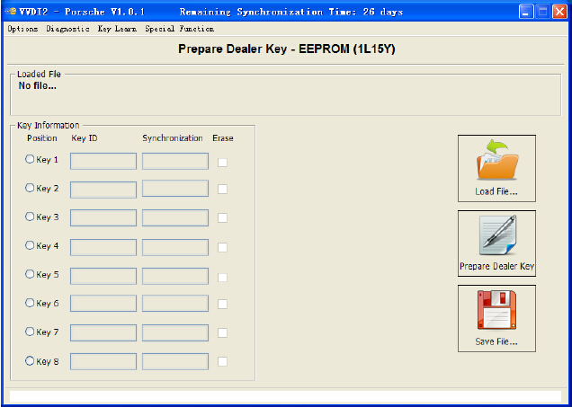  
  
**VVDI2 – Transponder Programmer software**  
Transponder programmer software is a multifunctional immo transponder tool. Mainly include: transponder programming, special transponder, immobilizer data tool, other key data, prepare remote etc.  
  
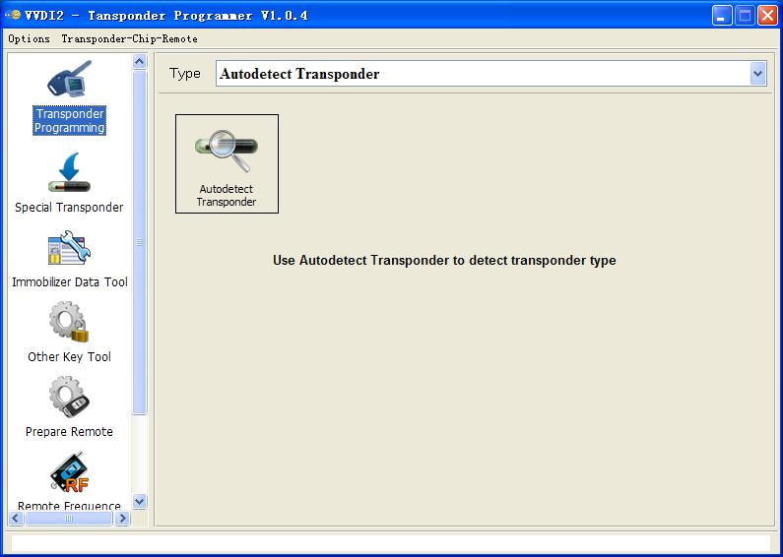  
  
**Transponder Programming:**  
Support many type transponder: Read/Write, Verify, Copy etc (Support auto detect function) Support following types:  
  PCF7930/PCF7931/PCF7935  
  HITAG2  
  HITAG2+ EE  
  HITAG2 Extended  
  HITAG3  
  HITAG Pro  
  HITAG (BMW)  
  HITAG (VAG)  
  MEGAMOS13  
  MEGAMOS48  
  MEGAMOS8E  
  TEMIC 11/TEMIC 12  
   TEMIC 8C  
  TIRIS 4C  
  TIRIS DST 4D/4E  
  TIRIS DST+  
  T5/TK5551  
  
**Special Transponder**  
Special Transponder, it can prepare a special transponder (original manufacture key). It can be learned to car with PIN code. Support following types:  
  TP22 (Seat-CAN) --- Megamos Crypto 48  
  TP23 (Volkswagen-CAN) --- Megamos Crypto 48  
  TP24 (Skoda-CAN) --- Megamos Crypto 48  
  TP25 (Audi-CAN) --- Megamos Crypto 48  
  ID33 Citroen/Peugeot/Fiat/Lancia VALEO --- PCF7935  
  ID33 Fiat BOSCH --- PCF7935  
  ID33 Mazda --- PCF7935  
  ID33 Mitsubishi --- PCF7935  
  ID33 Nissan --- PCF7935  
  ID33 Nissan 2 --- PCF7935  
  ID33 Opel/Vauxhall/Cadillac/Holden --- PCF7935  
  ID33 Opel/Vauxhall/Cadillac/Holden 2 --- PCF7935  
  ID33 Volkswagen --- PCF7935  
  ID40(44) China Cars --- PCF7935  
  ID40 Opel/Vauxhall/Cadillac/Holden --- PCF7935  
  ID41 Nissan --- PCF7935  
  ID42 Volkswagen --- PCF7935  
  ID44 Mitsubishi --- PCF7935  
  ID44 Volkswagen 1 --- PCF7935  
  ID44 Volkswagen 2 --- PCF7935  
  ID45 Peugeot --- PCF7935  
  ID46 China Cars --- PCF7936  
  ID46 VAG --- PCF7936  
  ID46 Nissan X-Trail  
  ID46 Nissan Platina  
  ID46 Nissan Keyless --- Key Card  
  ID46 Infinity Keyless --- Key Card  
  ID46 Nissan Micra --- Remote Key  
  ID46 Nissan Tida --- Remote Key  
  ID46 Renault Master II --- Remote Key  
  ID46 Renault Clio II --- Remote Key  
  ID46 Renault Master II --- Transponder 7936  
  ID46 Renault Trafic II --- Remote Key  
  ID46 Renault Trafic II --- Transponder 7936  
  ID46 Nissan Primastar --- Remote Key  
  ID46 Nissan Primastar --- Transponder 7936  
  ID46 Nissan Interstar --- Remote Key  
  ID46 Nissan Interstar --- Transponder 7936  
  ID46 Opel Astra H / Zafira B --- Remote Key  
  ID46 Opel Corsa D --- Remote Key  
  ID46 Opel Vectra C --- Remote Key  
  ID46 Opel Vivaro --- Remote Key  
  ID46 Opel Vivaro --- Transponder 7936  
  ID46 Opel Movano --- Remote Key  
  ID46 Opel Movano --- Transponder 7936  
  ID46 Opel Movano III --- Remote Key  
  ID46 Renault Master III --- Remote Key  
  ID46 Renault Clio III --- Remote Key  
  ID46 Renault Modus III --- Remote Key  
  ID46 Renault Espace IV --- Transponder 7936  
  ID46 Renault Espace IV --- Key Card 2-buttons  
  ID46 Renault Espace IV --- Key Card 3-buttons  
  ID46 Renault Laguna II --- Transponder 7936  
  ID46 Renault Laguna II --- Key Card 2-buttons  
  ID46 Renault Laguna II --- Key Card 3-buttons  
  ID46 Renault Laguna III --- Key Card  
  ID46 Renault Vel Satis --- Transponder 7936  
  ID46 Renault Vel Satis --- Key Card 2-buttons  
  ID46 Renault Vel Satis --- Key Card 3-buttons  
  ID46 Renault Megane II --- Key Card  
  ID46 Renault Scenic II --- Key Card  
  ID46 Renault Twingo --- Remote key  
  ID46 Renault Twingo --- Transponder 7936  
  ID46 Citroen/Fiat/Lancia/Peugeot --- PCF7936  
  ID46 Citroen/Peugeot --- PCF7936  
  ID46 Citroen/KIA/Hyundai/Peugeot --- PCF7936  
  ID46 Fiat/Iveco --- PCF7936  
  ID46 Renault/Chrysler --- PCF7936  
  ID46 Chrysler CAN bus (Y164,Y170) --- PCF7936  
  ID46 Chevrolet Circle Plus --- PCF7936  
  ID46 Mitsubishi --- PCF7936  
  ID46 Saab  
  ID46 Hyundai Remote key 7946  
  ID46 KIA Remote key 7946  
  ID60 Generic --- Texas 4D  
  ID61 Mitsubishi II --- Texas 4D  
  ID62 Suzuki BIKE --- Texas 4D  
  ID62 Kawasaki BIKE --- Texas 4D  
  ID62 Mitsubishi III --- Texas 4D  
  ID63 Ford/Mazda --- Texas 4D  
  ID64 Chrysler/Subaru --- Texas 4E  
  ID65 Suzuki/Subaru --- Texas 4D  
  ID66 Suzuki --- Texas 4D  
  ID67 Toyota --- Texas 4D  
  ID68 Lexus --- Texas 4D  
  ID69 Yamaha --- Texas 4D.(JMA TP31)  
  ID70 Toyota Europe --- Texas 4D  
  ID70E Toyota Hybrid --- Texas 4D  
  ID73 Mitsubishi --- PCF7935  
  ID8C Ford/Mazda --- Temic 8C  
  ID8C Proton --- Temic 8C  
  Mercedes Benz G- Class --- PCF 7930  
  Mercedes Benz C- Class/E- Class --- PCF 7930  
  Mercedes Benz ML --- PCF 7930  
  VW Jetta 2010 (China) --- Megamos Crypto 48  
  
**Immobilizer Data Tool**  
Immobilizer Data Tool, simply name write start. It can load car immobox EEPROM dump, make a working key directly. Provide detail transponder type and EEPROM type accord selected car. Support following car types:  
**Asia**  
Acura,Brilliance,Besturn,Chang An,Great,Wall,Chery,Daewoo,Daihatsu,Geely,Haima,Honda,Hyundai,Infiniti,Isuzu,Kawasaki,Kia,Lexus,Mazda,Mitsubishi,Nissan,Proton,SaicMotor,Saipa,IKCO,SsangYong,Subaru,Suzuki,Tata,Toyota,Yamaha  
  
**Euro**  
Alfa Romeo,Aprilia,Aston,Martin,Audi,Bentley,BMW,Citroen,Dacia,DAF,Ducati,Ferrari,Fiat,Gilera,Iveco,Jaguar,Lancia,LDV,MAN,Maserati,Mercedes Benz,Opel,Peugeot,Piaggio,Polonez,Porsche,Renault,Rover,Saab,Scania,Seat,Skoda,Smart,TagAZ,UAZ,VAZ,Volvo,VW  
  
**USA**  
Buick,Bombardier,Cadillac,Chevrolet,Chrysler,Dodge,Ford,GMC,Jeep,Lincoln,Oldsmobile,Pontiac  
**Other Key Tool**  
Mainly about unlock key made by VVDI2, find 7th byte CS from working key(VAG cars), make dealer key with 7 bytes CS(VAG cars), Change identifier for Megamos 48 transponder (Special transponder) etc.  
  
**Prepare remote**  
Write special programs to sub-remote-pcb with Remote Programmer; make the sub-remote-pcb have remote function as original new remote key It with offline database, auto update by internet You can provide your question and bugs here  
  
**VVDI2 – PassThru J2534 Configuration software**  
Support use Third – Party software connect to VVDI2 for communication. Requires the Third – Party software support SAE J2534 function.Now we support VAG diagnostics software: OIDS, VAS5054, Other Third – Party software will support in future. You can find detail in VVDI2 – PassThru J2534 User Manual  
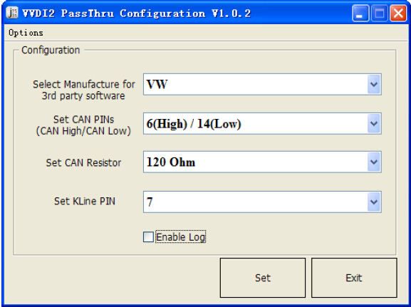  
  
**How to Update Xhorse VVDI2 Programmer?**  
Online Update Tool software can update your VVDI2 to newest firmware and download newest software  
You can find detail in VVDI2 – Update Online  
1.Close other VVDI2 software,connect VVDI2 to PC with USB cable  
2.Choose VVDI2 firmware version  
3.Press button "Update Online" to start  
Note:If failed,close antivrus and firewall software,try again.Don't shutdown your PC or disconnect USB cable when updating.  
  
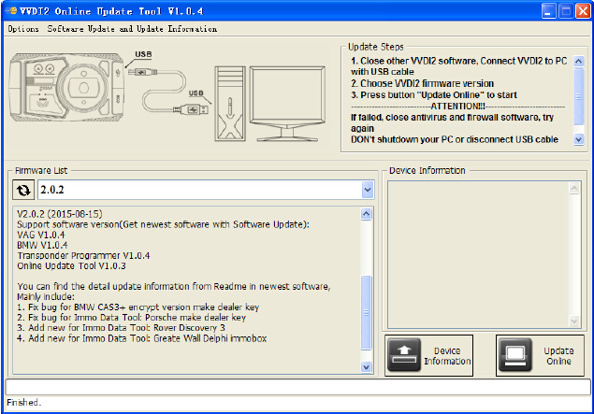  
  
  
**Xhorse VVDI2 Package List:**

VVDI 2 Main Interface  
5th BDM Programmer  
OBD2 Cable  
Remote Programmer  
USB Cable  
CAS Plus (additional part, need to buy alone)